CS155b: Graphics | Devi Acharya | PA4: Raytracer Paper
For PA4 I worked on adding a fog component to the raytracer. The fog component looks at each rendered pixel’s distance to the camera, and depending on how far away the object is supposed to be, mixes some white into the rendered pixel, creating a fog-like effect where far-away objects appear to be very white and close-up objects appear to be somewhat white, as if the objects are surrounded by fog.
The high-level explanation—the fog code modifies Scene.js, which deals with how the scene is rendered. For adding the fog component, I placed code in the GetColorForRay() method that would average the current theColor with white depending on the length of the ray (distance from the camera). I then added elements to the Scene.js constructor that would take in both a Boolean (hasFog) and a float (fogAmt) so that when the user creates the scene, they can specify whether then scene has fog, and if it does, specify how intense it is.
The code—here are the lines I added or modified in Scene.js:
constructor(name, hasFog, fogAmt){
…
this.hasFog = hasFog
this.fogAmt = fogAmt //0 to 1
}
getColorForRay(ray,depth){
…
if (this.hasFog){
theColor = Color.average(ray.len - (1 - this.fogAmt),Color.WHITE,theColor)
//0 fogamt is less fog, 1 is more fog
}
return theColor

How this code works—the constructor of the scene takes a Boolean for hasFog and a double for fogAmt, allowing the user to specify how much or how little fog they want, and whether they want the scene to be rendered with fog at all. You can see in the getColorForRay() function that it first checks if the scene is supposed to have fog. If not, it will not modify the color based on fog amount. If it is supposed to have fog, however, it will then take the color that the pixel is supposed to be (theColor) and average that with white. It weights that average using the length of the ray minus a certain amount (I found that minus a value between 0 and 1 worked best for providing a range of different fog variants). this.fogAmt is the value taken in by the constructor, and the reason the function subtracts 1 – this.fogAmt from ray.len is so that a user value of 0 results in a low amount of fog, and a user value of 1 presents a high amount of fog, with a range in between.
This doesn’t interact with a lot of the other raytracer systems except indirectly (for instance, it relies on a different system that calculates theColor so that it can modify theColor in the Scene.js file).

Images—
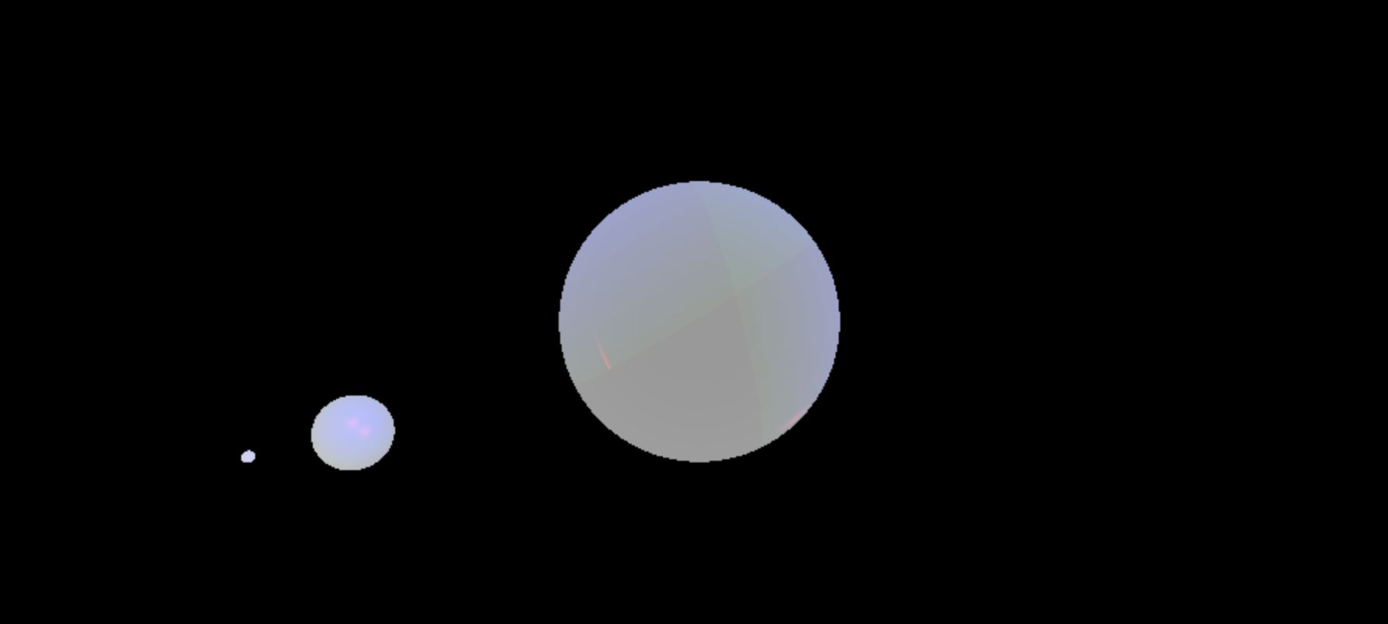
High fog (.6)

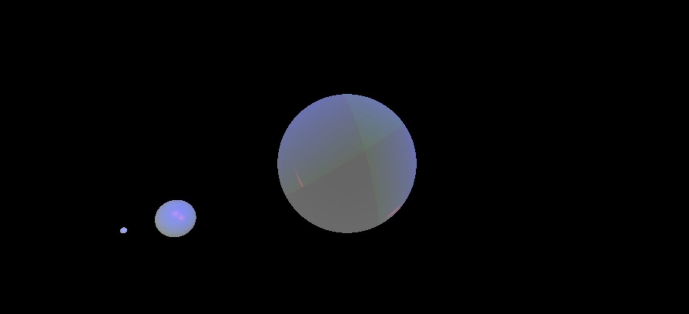
Medium Fog (.4)
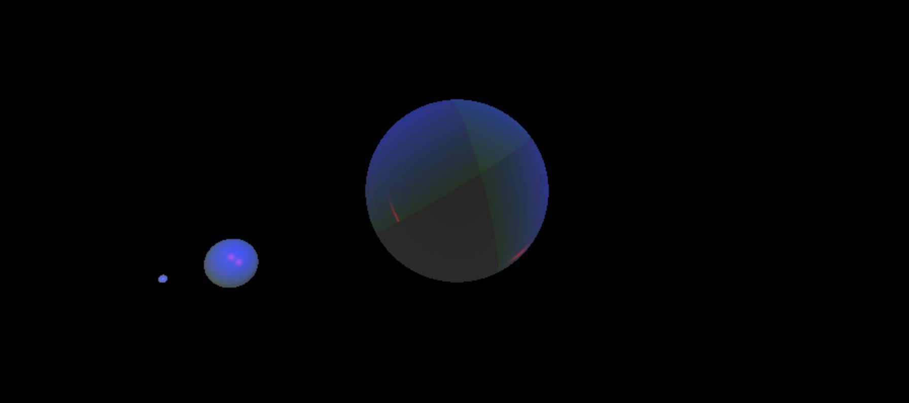
Low fog (.2)

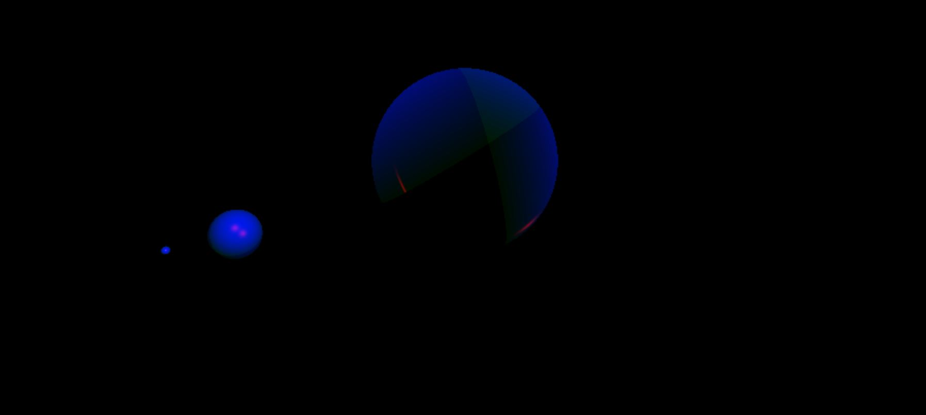
No fog (hasFog = false)

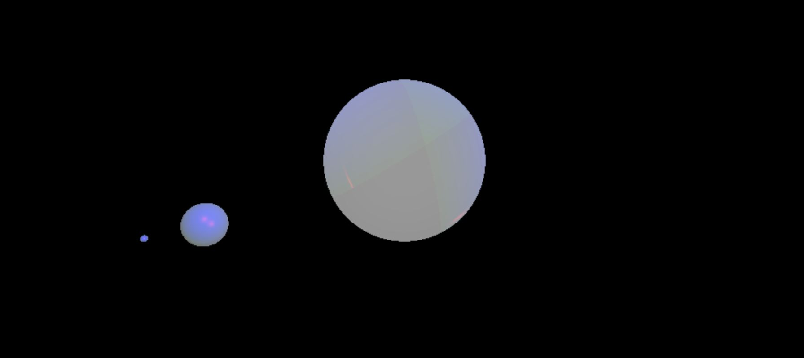
Inverted fog (not currently accessible to user, but the idea is closer things have more white mixed in than farther things)

These images were gathered using three different spheres of the same size with the same material, at different distances.
Here’s the code:
const s1 = new Sphere()
s1.material = new Material(Color.GREEN,Color.BLUE,Color.RED)
s1.material.shininess = 100
s1.translate(new Vector3(0,5,0))
.scale(new Vector3(3,3,3))
scene.addObject(s1)
//
const sx = new Sphere()
sx.material = new Material(Color.GREEN,Color.BLUE,Color.RED)
sx.material.shininess = 100
sx.translate(new Vector3(-50,10,0))
.scale(new Vector3(3,3,3))
scene.addObject(sx)

const sz = new Sphere()
sz.material = new Material(Color.GREEN,Color.BLUE,Color.RED)
sz.material.shininess = 100
sz.translate(new Vector3(-400,50,0))
.scale(new Vector3(3,3,3))
scene.addObject(sz)

And here are some images from my own scene that use the fog code.

Before fog:
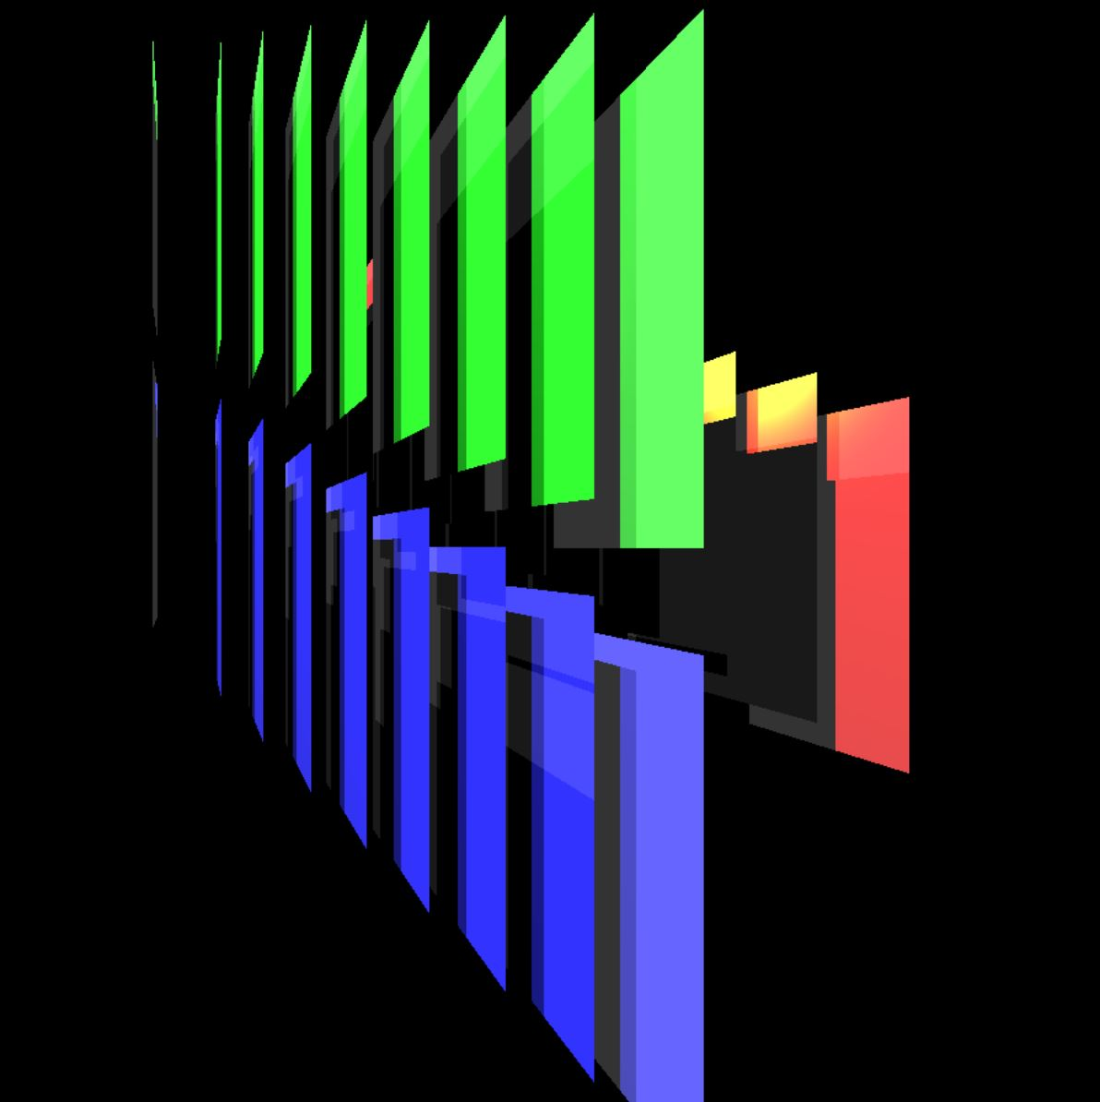

After fog:
